Gwenfro Community Primary School

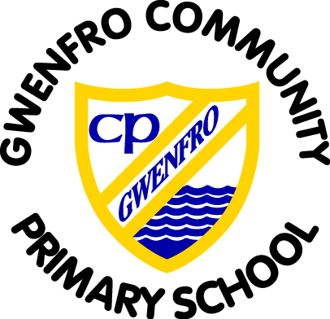

Curriculum Policy
2024

Agreed by the Governing Body
Chair of Governors: D. Jacks
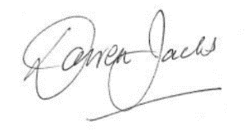

WELCOME TO OUR SCHOOL
The United Nations Convention on the Rights of the Child (CRC) is at the heart of Gwenfro School’s planning, policies, practice and ethos. As a rights-respecting school we not only teach about children’s rights but also model rights and respect in all relationships. Our belief in “restorative approaches” ensures that every child is listened to. We believe that every member of the school community; pupils, staff and parents are a learner. Together we develop as a learning organisation, using information from research, other schools, businesses and the real world to build a culture for improvement.

Vision Statement
We aspire for all our children to become confident, secure, caring individuals who achieve personal success. They are given every opportunity to achieve their full potential, develop a love of learning, acquire skills to become life-long learners and the ability to make informed choices.

As we move forward through curriculum reform in Wales, we have been working towards a vison and curriculum map for the pupils at Gwenfro based on the voice of all stakeholders .
This is an ongoing process.

Equalities
Every effort is made to ensure that teaching and learning provides equal entitlement of the curriculum for all children who attend Gwenfro CP irrespective of race, religion or belief, gender, age, disability and language. Sensitivity and fairness is emphasised during monitoring and assessment to take into account equality of opportunities. Each child is valued and seen as unique. We endeavour to ensure the curriculum and learning and teaching opportunities cater for the learning needs of the individual pupil with the aim of stretching them to the full extent of their capabilities and providing them with the opportunity to demonstrate fully what they know, understand and can do. The children’s wellbeing is always central to everything we do.

CURRICULUM AIMS
At Gwenfro Community Primary School we aim to:
• create a happy welcoming school environment that respects the UNCRC’s Rights of the Child.
• deliver a “four purpose” driven curriculum
• develop each individual to their potential through offering a wide range of high quality skills and knowledge based experiences.
• enable optimum progression of each individual to develop their talents and skills through a wide range of high-quality skills and knowledge-based experiences.
• encourage a love of learning and high levels of confidence through a growth mindset approach.
• develop effective thinking, independent learning and the ability to solve problems creatively.
• use every opportunity to develop the skills of Numeracy, Literacy and Digital Competency enabling each child to experience achievement at all levels.
• enable pupils to be given progressive responsibility for organising their learning and management of time.
• enhance self-worth and the ability to value each person’s own worth through a caring, secure environment. This will develop sensibility to others, self-discipline, high self-esteem and acceptable behaviour.
• develop imagination and creativity by offering wide range of authentic experiences.
• develop the natural curiosity that children exhibit about themselves and their world, and use their curiosity to foster positive attitudes to learning.
• develop an appreciation of the heritage and history of Wales, through authentic contexts, as well as learning the Welsh language.

OUR SCHOOL STRUCTURE- we are trailing a new approach based on the progression steps.
- Early Years-Nursery and Reception (PS1)
- Year 1 (PS1/2)
- Year 1/2 (PS2)
- Year 2/3 (PS2)
- Year 3 (PS2)
- Year 4 (PS3)
- Year 4/5 (PS3)
- Year 5/6 (PS3)
- Year 6 (PS3)
- Resource Provision (FP and Key Stage 2)

Teachers work together to ensure consistency and progress of learning. We develop skills through teaching in varying group sizes, through a range of pedagogical approaches.

We are currently trialling aspect of the new Curriculum for Wales (CfW).

A PURPOSEFUL, AUTHENTIC & RELEVANT CURRICULUM
A new curriculum is being developed for settings and schools in Wales. A final version has been available since January 2020, and will be used throughout Wales by 2022. The principles underpinning every Area of Learning and Experience (AoLE) in Gwenfro Community Primary ensures that the curriculum is:-
• authentic: rooted in Welsh values and culture and aligned with an agreed set of stated purposes
• evidence-based: drawing on the best of existing practice within Wales and from elsewhere, and on sound research
• responsive: relevant to the needs of today (individual, local and national) but also equipping all young people with the knowledge, skills and dispositions for future challenges as lifelong learners
• inclusive: easily understood by all, encompassing an entitlement to high-quality education for every child and young person and taking account of their views in the context of the United Nations Convention on the Rights of the Child (UNCRC), and those of parents, carers and wider society
• ambitious: embodying high expectations and setting no artificial limits on achievement and challenge for each individual child and young person
• empowering: developing competences which will allow young people to engage confidently with the challenges of their future lives •unified: enabling continuity and flow with components which combine and build progressively
• engaging: encouraging enjoyment from learning and satisfaction in mastering challenging subject matter
• based on subsidiarity: commanding the confidence of all, while encouraging appropriate ownership and decision making by those closest to the teaching and learning process
• manageable: recognising the implications for and supported by appropriate assessment and accountability arrangements.
• rights-based: underpinned by the principles of the United Nations Convention on the Rights of the Child.

We believe that to get the best out of all our learners (and that includes staff) we have to offer rich and exciting experiences. We are committed to developing a curriculum which engages, enthuses and inspires our pupils and staff. We encourage teachers to have the freedom to teach in ways they feel will have the best outcomes for their learners. We have a strong emphasis on the acquisition and application of skills and knowledge through experiential and active learning. We study a whole school topic each term. All children contribute to their curriculum, ensuring that they have ownership over their learning, through class planning at the beginning of each term.

Across all Areas of Learning and Experience (AoLEs), the application of numeracy, literacy and digital competency is robustly planned for. Teachers are expected to plan and deliver learning intentions pitched appropriately to the learners needs. Lessons have success criteria to ensure the learners are aware of the particular skills they are looking to develop within that lesson. In addition to literacy, numeracy and digital competence, teachers plan for incidental welsh and opportunities for diversity in line with the new CfW. There is a whole school approach to well-being enabling pupils to understand their own and others’ emotions. This is in line with the Health and Well Being AoLE, and is integrated throughout the school day, and throughout the curriculum itself.

PLANNING AND PREPARING FOR LEARNING
Our curriculum places emphasis on equipping young people for life. It provides pupils with opportunities to learn new skills and apply their knowledge positively and creatively. Learners are provided with understanding of how to thrive in an increasingly digital world. We follow a digital competence framework developing digital skills across the curriculum, and preparing them for the opportunities and risks that an online world presents. All teachers ensure that learners are planned for ambitiously, at a progression step relevant to their need. Each AoLE has a number of What Matters statements, which ensure breadth, and coverage of the fundamental key concepts. As a guide to planning, the school has mapped out expectations for each year group in the table below. However, learners may be above or below the descriptions of learning within that particular progression step. A child’s progression step is not a 'best fit' model but a way to genuinely plan for an individual's progression in different areas of learning

Teachers use their PPA time effectively to plan, prepare and assess learning within their classes. This takes the form of the skills, knowledge and experiences that each child needs to be able to progress.

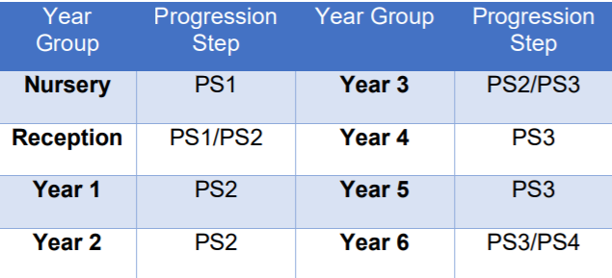

We are working towards the curriculum is the whole learning experience offered by our school. It is not only the lessons and activities, but also the attitudes and values we promote. This is achieved through integrating the Four Purposes into all our planning. These are explicit to the learners. Our curriculum is enriched, engaging, broad, balanced and relevant to our learners. It ensures progression and continuity for the pupils and provides opportunities for children to acquire knowledge, skills and values through a variety of experiences.

CURRICULUM FOR WALES (CfW)
The four purposes will be at the heart of our new curriculum. They are the starting point for all decisions on the content and experiences developed as part of the curriculum. More than that, they are designed to influence how practitioners plan, teach and assess.
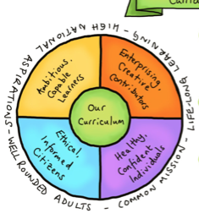

1. Ambitious, capable learners who:
- set themselves high standards and seek and enjoy challenge – are building up a body of knowledge and have the skills to connect and apply that knowledge in different contexts
- are questioning and enjoy solving problems – can communicate effectively in different forms and settings, using both Welsh and English
- can explain the ideas and concepts they are learning about – can use number effectively in different contexts
- understand how to interpret data and apply mathematical concepts
- use digital technologies creatively to communicate, find and analyse information
- undertake research and evaluate critically what they find and are ready to learn throughout their lives

2. Enterprising, creative contributors who:
- connect and apply their knowledge and skills to create ideas and products
- think creatively to reframe and solve problems – identify and grasp opportunities
- take measured risks
- lead and play different roles in teams effectively and responsibly
- express ideas and emotions through different media
- give of their energy and skills so that other people will benefit and are ready to play a full part in life and work

3. Ethical, informed citizens who:
- find, evaluate and use evidence in forming views
- engage with contemporary issues based upon their knowledge and values
- understand and exercise their human and democratic responsibilities and rights
- understand and consider the impact of their actions when making choices and acting
- are knowledgeable about their culture, community, society and the world, now and in the past
- respect the needs and rights of others, as a member of a diverse society
- show their commitment to the sustainability of the planet and are ready to be citizens of Wales and the world

4. Healthy, confident individuals who:
- have secure values and are establishing their spiritual and ethical beliefs
- are building their mental and emotional well
- being by developing confidence, resilience and empathy
- apply knowledge about the impact of diet and exercise on physical and mental health in their daily lives
- know how to find the information and support to keep safe and well
- take part in physical activity
- take measured decisions about lifestyle and manage risk
- have the confidence to participate in performance
- form positive relationships based upon trust and mutual respect
- face and overcome challenge
- have the skills and knowledge to manage everyday life as independently as they can and are ready to lead fulfilling lives as valued members of society.

Curriculum for Wales 2022 organises learning around six areas of learning and experience which are:

Six Areas of Learning and Experience:
1. Language, literacy and communication
2. Mathematics and Numeracy
3. Humanities
4. Health and Wellbeing
5. Science and Technology
6. Expressive Arts

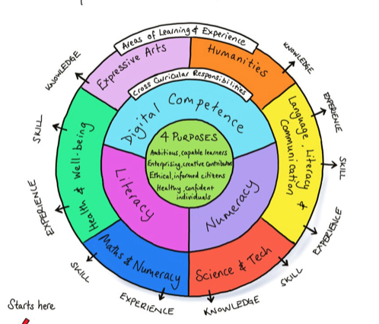

Each of the areas of learning and experience has been designed to support learners to realise the four purposes of the curriculum. They are intended to promote collaboration and cross-disciplinary school-level curriculum development and design.

All teachers plan for the cross-curricular responsibilities of literacy, numeracy and digital competence to support almost all learning. These are essential for learners to be able to participate successfully and confidently in the modern world.

AOLE TEAM
At Gwenfro, each teacher is member of an AOLE team, based on their expertise and wider interest. As we move forward in designing a curriculum for Gwenfro CP School, each AOLE team will take increased responsibility for supporting the content and development of their ‘area’.
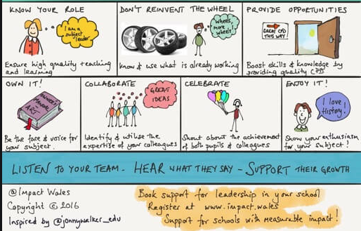

INTEGRAL (WIDER) SKILLS
Throughout the curriculum, meaningful and authentic experiences will provide opportunities to develop the wider skills, developing the resilience to face present and future challenges throughout their life.

1. Creativity and Innovation
2. Critical Thinking and Problem Solving
3. Planning and Organisation
4. Personal Effectiveness

PEDAGOGY
How children learn is as important as what they learn. Our teachers teach through a range of approaches, not restricted, but including those outlined in the 12 Pedagogical Principles.
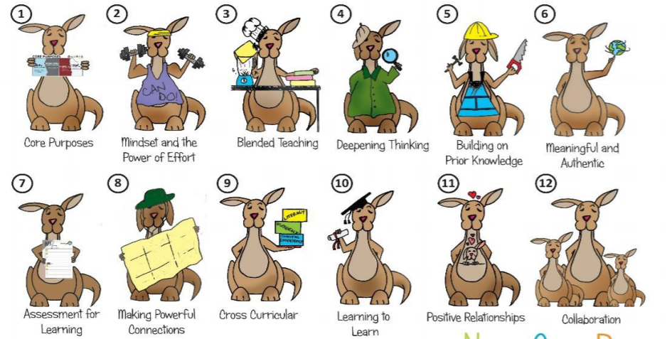

THE LEARNING ENVIRONMENT
The physical and emotional learning environment at Gwenfro Community Primary reinforces our commitment to high standards and the drive to continually raise achievement. The learning environment is a means of adding greater depth and breadth to pupils’ learning. We believe it plays an important role in supporting the well-being of our learners. It raises self-esteem, celebrates what we do and encourages pride in the classroom and school.

The school’s aims for the learning environment are:
- to motivate children by setting high standards to which they can aspire
- to support independence and active learning
- to encourage collaboration
- to celebrate achievement
- to create a stimulating teaching and learning environment
- to encourage aesthetic awareness and a positive attitude to our school environment
- to arouse curiosity, pose questions and stimulate enquiry
- to increase children’s self-esteem and pride in their work
- to reflect and value different levels of achievement and cultural backgrounds
- to inform and inspire parents, carers, governors, teachers and visitors to the school

Individual teachers are responsible for the learning environment within their own classrooms and designated areas. The learning environment, whether indoor or outdoor, should be calm, welcoming, organised and stimulating places where high value is placed on learning.
The environment needs to be considered in terms of:-
• How it looks eg organised
• How it sounds eg calm
• How it smells eg clean
• How it feels eg comfortable

A calm environment is not necessarily a quiet one. By calm we mean children are:
• on task
• aware of acceptable noise levels for classwork and teachers help to maintain this by example
• taught to tidy up after themselves
• aware of the rules and boundaries
• able to access resources they require
• provided with appropriate amount of room for the activity.

DISPLAYS AT GWENFRO CP SCHOOL
At Gwenfro Community Primary we use displays to enhance and promote learning. We ensure that displays:
• engage the audience and/or stimulate interest in a topic. Theme or unit of work
• Model high expectations of presentation and handwriting
• ensure reflection of a broad and balanced curriculum and always include work related to literacy and numeracy
• contain key and technical vocabulary relevant to the focus of the learning is evident in all subjects
• maintain balance between celebration and information
• use various styles, strategies and subjects
• be current - all work on display is up to date and represents learners currently in the class
• celebrate children’s work and evidence our community/ethnic mix
• be used actively and purposefully
• ensure that all learners are represented
• be 3D where possible and creative (and include use of relevant text books and artefacts)
• have a variety of techniques and media employed in artistic displays
• learner’s drawings, writing and other representational work to be original
• have learners own drafted independent writing on display. (It is acceptable to have some mistakes in pieces of extended writing or teachers’ marking/feedback on the work)
• have a title and labels (bilingual – Welsh /English /other languages as appropriate) which include information, facts and questions
• introduce, summarise or reinforce knowledge and skills
• Accessible to its audience ie right height and size for reading

There are four main types of display:
1. Interactive - where children have the opportunity to interact with the display either during the main teaching input or as part of their lesson or informally to extend their learning beyond the lesson. Interactive aspects should be multisensory.
2. Celebratory - reflecting the Curriculum coverage and standards for that particular year group
3. Informative – A learning wall where children can get information eg Times tables reckoner, WoW words.
4. Working walls - Work is not necessarily mounted as it is expected to develop rapidly and change frequently eg work of the week and supports everyday teaching and learning.

EXPECTATIONS FOR LEARNING
We have very clear expectations of the staff, pupils and the environment in which we all learn. The teachers will:
• keep a consistent focus on the four purposes of the curriculum
• challenge all learners
• encourage sustained effort and growth mindset
• use a blend of pedagogical approaches to promote problem solving, creative and critical thinking
• build upon previous knowledge
• create authentic contexts for learning
• employ assessment for learning principles
• teach across all areas of learning and experiences
• reinforce cross-curricular responsibilities including literacy (Welsh and English), numeracy and digital competency
• provide opportunities for pupils to practice their skills in real life situations
• encourage pupils to take responsibility for their own learning
• support social and emotional development
• encourage independence and interdependence
• value the four purposes within their planning

The pupils will:
• build from what they know
• make choices to support their learning
• ask questions about their learning
• value their own and others’ ideas
• learn from their mistakes
• make choices about their learning including when to use ICT
• have time to reflect on own and others’ work
• challenge themselves
• use a range of approaches to learning
• enjoy working together and on their own

The school environment will provide:
• experiences of real life problems and situations
• a safe comfortable, inspiring place for learning
• appropriate technology to inspire creative learning
• enjoyable opportunities for outdoor learning.
• learners with opportunities to care for and manage their natural world

MEETING THE LEARNING NEEDS OF ALL PUPILS
The school has clear procedures for supporting pupils with additional Learning Needs (ALN) and these are outlined in the school’s ALN Policy. Additional support includes differentiated work with the class teacher, time spent in small groups or with the help of outside agencies. Individual Development Plans (IDPs) are used to focus upon the child’s needs and next steps. We believe strongly that all teachers are teachers of learners with Additional Learning Needs.

In Gwenfro, we believe that all children should be challenged in order to reach their potential. Feedback to pupils is clear, and staff ensure that pupils understand their next steps, and/or what they need to do to improve their work. The school has a robust Marking and Feedback Policy providing all staff with a consistent, yet progressive approach to feedback to pupils.

MONITORING THE CURRICULUM
Coverage, planning and standards of teaching and learning, is conducted by the Headteacher and Deputy Headteacher (See Monitoring Policy)

CONCLUSION
This policy should be read in conjunction with the National Curriculum Orders and Statutory Requirements and all NC policies, The new Curriculum for Wales documents, the ALN Bill, Assessment policy and Marking policy.

The curriculum in Wales is changing. Gwenfro Primary is keeping abreast of new developments. The 12 pedagogical principles and core purposes are already embedded. This policy will be reviewed as and when is needed in conjunction with new developments.

